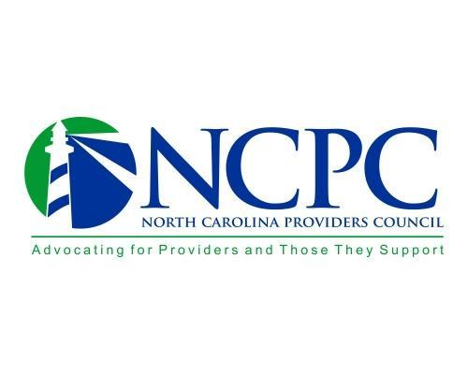

**NC Providers Council** **Operational Data Strategies Committee Meeting Agenda**

**July 28, 2021, 12 noon – 1 pm**

**Welcome and Introductions –** *Vanessa Ervin, Committee Chair*

**Ongoing Business -** *Vanessa Ervin, Committee Chair*

* **EVV Payment Issues –** *Chris Thompson/Sarah Pfau*
* **Tailored Care Management –** *Chris Thompson*

**New Business -** *Vanessa Ervin, Committee Chair*

* **Legislative Updates** – *Joel Maynard*
* **NC Medicaid Quality Plan** – *Vanessa Ervin*
* **IRIS Updates** – *Vanessa Ervin*

**Next meeting:**  September 29th 12 noon – 1 pm

Attendees:

* Vanessa Ervin
* Chris Thompson
* Jamie Garrett
* Rachel Jordan
* Julie Bowden
* Ramses Diaz
* Helen Austin
* Joel Maynard
* Teri Herrmann
* Doug Finley
* Sheryl Zerbe
* Sarah Pfau
* Kelly Husn
* Devon Cornett
* Fred Nirde

Opening Discussion

EVV issues

* Fewer of the client not found errors this week
* HHA side: running manual work arounds – reprocessed the next day
* # 3 most of the way the complete
* # 1 seems to be rectified through Sendata

Tailored Care Management

Legislative Issues

* Standing still currently
* When a legislator on break, good time to meet with them
* House Committee Chairs
* Hopefully next week, something for us to look at from the House on a budget
  + How they fund DSP wage increase?
    - How they fund long term
    - $1500 could only be used for DSP’s that stayed with their current organization
* September 1 – being completed and head towards the budget

Quality Plan

* Need to review and offer feedback
* Value Based HCP-Lan Graphic attached:

Standard Plans and Tailored Plans may implement Value-Based Contracting on a “glide path.”  The Department requires that by the end of Year 2 of Standard Plan operations, the portion of each Standard Plan’s medical expenditures governed under VBP arrangements will either increase by twenty (20) percentage points or represent at least fifty percent (50%) of total medical expenditures.    NC DHHS has based its VBC strategy and provider expectations and targets on the Health Care Payment Learning & Action Network’s framework (the graphic).  DHHS has not required any one specific approach to Standard Plan VBC; however, DHHS requires Standard Plans to operate somewhere within Categories 2 – 4.

NC DHHS has a Quality Strategy that was incorporated into the Request for Proposals for the Standard Plans and the Request for Applications for the Tailored Plans.  The Quality Strategy will *also* be implemented on a “glide path.”  DHHS states, “Over time, Standard Plans and Behavioral Health I/DD Tailored Plans should plan for an increasing proportion of provider contracts to be in advanced payment models that may require alternative approaches to contracting, data sharing, and provider and enrollee engagement.”  The graphic below maps out Contract Years 1 – 3 for both Standard Plans and Tailored Plans.  Please see the complete 111-pg. *Quality Measurement Technical Specifications Manual* published in May of 2021 [here](https://medicaid.ncdhhs.gov/media/9025/download).

Please also see pages 19-27 of this [NC DHHS Policy Paper](https://www.ncdhhs.gov/media/9005/download) for the Tailored Plan Quality Metrics that will be reported.

