Presented in 3/25 Joint Appropriations Committee Meeting:
- Governor’s Recommended Budget SFY2021-2023
- 3/25 Governor’s Budget 1-page “Long Sheet” as presented to the NCGA
- 3/25 Office of State Budget and Management presentation [22 slides] to the NCGA
Within the full Governor’s Recommended Budget:
- DHHS snappys begin on pg. 140.
- Division of Health Benefits snappys begin on pg. 146.
- DMH/DD/SAS snappys begin on pg. 149.
- Division of Health Services Regulation snappys begin on pg. 151.
Note these are document page numbers and not .PDF file page numbers.
Summary of IDD snappys of interest from the DD Consortium:
- 520 waiver slots, funding for workforce issues
- $5M for transportation (Integrated Mobility - Rural Operating Assistance Program)
- $60M to address wages for direct care/support and early childhood workforce (funds are across children, aging and disabilities)
- $30M for increased housing and employment for people with disabilities ($15M housing trust fund)
- $305M for resources for at-risk children, including special education (removes funding caps, increases allocations)
- $1.5M for reducing the implicit bias of students of color and students with disabilities in early education
- $10M in funds for individualized early intervention
- $250M in Medicaid to address social determinants of health
- Also funds benefits counseling in Voc Rehab, adaptive equipment, and other items not mentioned above.

Select Education provisions summarized 3/25 The Insider:
- $15 an hour minimum wage for noncertified, public school employees including teaching assistants, cafeteria workers and bus drivers.
  - NOTE: the budget also includes a 5% raise for State employees, so the legislated 2018 $15/hour floor would be even higher.
- $80 million for more school nurses, counselors, psychologists and social workers.

From Joint appropriations /Base Budget meeting on 3/25:
$230M to eliminate caps and expand funding for children with disabilities and several additional populations

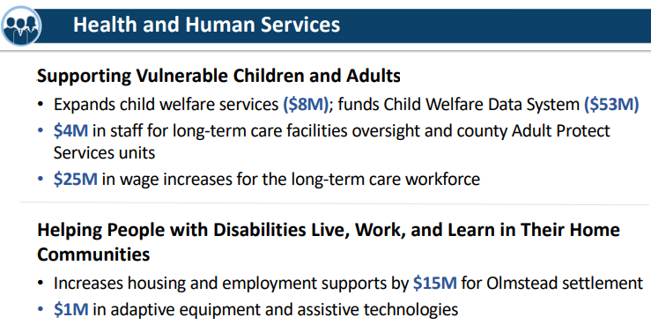

Discussed in House Health Committee:

S103 Edition 4 (now 11 pages): Reduce Reg. to Help Children with Autism
[Counterpart bill: H91]

Long Title: A BILL TO BE ENTITLED AN ACT TO REDUCE UNNECESSARY REGULATORY CONSTRAINTS FOR APPLIED BEHAVIOR ANALYSIS

Discussed in the House Judiciary Committee This Week: PCS/HB212 – Social Services Reform
An act to implement various provisions related to social services reform and to repeal certain changes to the adoption laws
- The Proposed Committee Substitute (PCS) would make the following changes:
  - Implement new supervisory requirements recommended by the Social Services Regional Supervision and Collaboration Working Group (Working Group) and appropriate funds for new staff positions
  - Require members of the county board of social services to attend education and training sessions
  - Require agencies to conduct feasibility and cost studies
  - Require the Social Services Commission to adopt rules and procedures regarding conflicts of interest
  - Extend deadlines for the reporting plans developed by the Working Group and address membership and vacancies in the Working Group
  - Repeal certain provisions relating to the Interstate Compact on the Placement of Children

Discussed in House State Government Committee this week:
H 173 Separate Divs-Juv Justice and Adult Corr.-AB

Discussed in Senate Commerce and Insurance this week:

S146 Teledentistry/RDH Admin. Local Anesthetic

S173 Occupational Therapy Interstate Compact

FILED BILLS OF INTEREST week of 3/22/2021

Filed on 3/24: H389v0.pdf (ncleg.gov) - North Carolina Innovations Waiver Act of 2021
[Senate counterpart bill: S350]
Long Title: A BILL TO BE ENTITLED AN ACT TO INCREASE THE NUMBER OF NORTH CAROLINA INNOVATIONS WAIVER SLOTS, TO PROVIDE THE DEPARTMENT OF HEALTH AND HUMAN SERVICES, DIVISION OF HEALTH BENEFITS, THE FLEXIBILITY TO DEVELOP AN ADDITIONAL SYSTEM OF SERVING INDIVIDUALS WITH INTELLECTUAL OR DEVELOPMENTAL DISABILITIES WHO ARE ON THE REGISTRY OF UNMET NEEDS, AND TO REQUIRE THE DEVELOPMENT OF A TEN-YEAR PLAN TO ADDRESS THE REGISTRY OF UNMET NEEDS
The bill’s proposed effective date is when it is signed into law and it would:
- Authorize and appropriate funding for 1,000 additional Innovations Waiver slots to be available January 1, 2022
  - 800 slots to be allocated with current formula
  - 200 slots to be allocated with either a proposed new formula or the current formula if DHHS cannot get timely CMS approval for the proposed new formula
- Appropriate an SFY2022-23 budget of approximately $13.1M in recurring funds for the State match for the Innovations Waiver program operation
- Authorize but not require DHHS to pursue a CMS-approved Innovations or 1115(c) Waiver amendment to offer as many Innovations Waiver slots as possible via possible tiered acuity eligibility categories
  - Lower tiers would have lower spending caps and higher tiers would have higher spending caps
  - LME/MCOs would retain the administrative authority to “determine how to best distribute funding in order to serve a greater number of individuals on the registry.”
  - If DHHS cannot obtain CMS approval for such a Waiver by January 2023, appropriated funding must be used to provide “no less than” 1,000 additional Innovations Waiver slots “as soon as practicable.”
- Require DHHS to convene a stakeholder workgroup to develop a 10-year plan to address the Registry of Unmet Needs.
  - The plan could include recommendations for a new Waiver program or alternative means for distributing Waiver slots.
  - DHHS would be required to include a cost analysis for all plan recommendations and proposed methods.
  - Would require the Division of Health Benefits to submit a report to the JLOC on Medicaid and NC Health Choice by February 1, 2022.

H351 - Clifford’s Law
Long Title: A BILL TO BE ENTITLED AN ACT DIRECTING THE SECRETARY OF THE DEPARTMENT OF HEALTH AND HUMAN SERVICES TO ESTABLISH VISITATION PROTOCOLS FOR NURSING HOMES, COMBINATION HOMES, AND HOSPICE CARE FACILITIES DURING DECLARED DISASTERS AND EMERGENCIES AND REQUIRING THESE FACILITIES TO ADHERE TO THE ESTABLISHED VISITATION PROTOCOLS DURING DECLARED DISASTERS AND EMERGENCIES WHEN NORMAL VISITATION POLICIES ARE SUSPENDED OR CURTAILED.
*On a ‘watch’ list in case NCPC member facilities of interest get added to this bill.
H346 – Funds for Down Syndrome Programs
Long title: AN ACT APPROPRIATING FUNDS TO THE DEPARTMENT OF HEALTH AND HUMAN SERVICES, DIVISION OF MENTAL HEALTH, DEVELOPMENTAL DISABILITIES AND SUBSTANCE ABUSE SERVICES, FOR DOWN SYNDROME PROGRAMS.
“The Department shall not allocate funds appropriated under this section to any program that does not have a proven record of providing at least one of the following services to adult individuals with Down Syndrome: (1) Assistance with dignified integration into the community. (2) Housing assistance. (3) Job training, job placement, or both.”
H347 – Healthy Students – Nurses in Every School
[counterpart bill = S331]
H348 - Add School Nurses for Healthier Students
H364 – Funds for the Expansion of NC pre-K
H366 – Regulatory Reform Act of 2021
*On a ‘watch’ list in case provisions of interest get added to this bill. As of now contains provisions re: pre-K schools, Division of Emergency Management, and one or two other potentially relevant provisions. Nothing directly related to DHHS at this time.
H410 - Repeal Certificate of Need Laws
H382 – Hospital ED Care/Medicaid Behav. Health Ser.
Long title: AN ACT TO REIMBURSE HOSPITALS FOR BEHAVIORAL HEALTH SERVICES PROVIDED TO MEDICAID BENEFICIARIES AWAITING DISCHARGE OR TRANSFER FROM A HOSPITAL SETTING TO A MORE APPROPRIATE SETTING.
H383 – Medicaid Modernized Hospital Assessments
Long title: AN ACT TO REVISE THE HOSPITAL ASSESSMENT ACT TO ACCOUNT FOR MEDICAID TRANSFORMATION
H395 – Extend Deadlines for Mandatory HIE Particip.
S353 – Modernization of Drug Court Program

