  - 2019 SPONSORSHIP AND EXHIBIT OPPORTUNITIES

  - 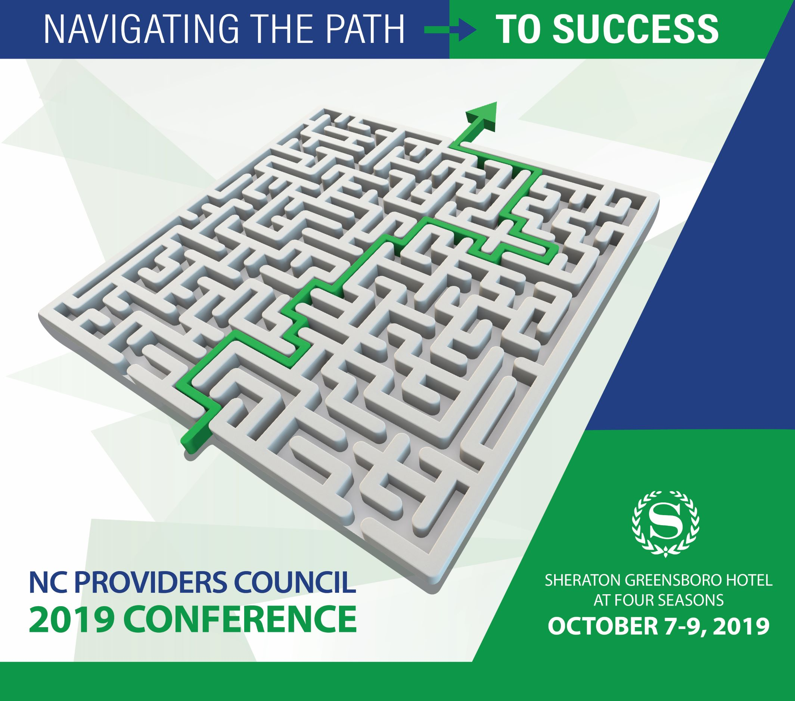
$5000 Elite
Includes one-year affiliate membership (a $2000 value), acknowledgement as the Keynote Speaker Sponsor, Exhibit Booth with electricity in prime location, registration for 3 representatives, your logo on a Conference App banner both mornings, sponsorship of 3 posts by NCPC, and promotional links and documents on your Sponsor page.

$3000 Platinum
Closing Session Breakfast Sponsor, Exhibit Booth in high-traffic location with registration for 2 representatives, your logo on a Conference App banner during Closing Session Breakfast, sponsorship of 2 posts by NCPC, and promotional links and documents on your Sponsor page.

$2000 Gold
Reception Sponsor with acknowledgement at our complimentary evening receptions, Exhibit Booth in a high-traffic location with registration for 2 representatives, your logo on a Conference App banner during the Receptions with an NCPC sponsored post, and promotional links and documents on your Sponsor page.

$1000 Silver
Morning and afternoon Coffee Break Sponsor, Exhibit Booth in high-traffic location, registration for 1 representative, with your logo on a Conference App banner during Coffee Breaks, and promotional links and documents on your Sponsor page.

As a valued sponsor, your organization will be recognized throughout the conference and on rotating Power Point presentations before each session begins. You may display signage in high traffic areas, and we will display your logo on our conference promotions, and on the conference website.

Exhibit Booth for Members: $400, Extra Representatives $75 each
Exhibit Booth for Non-Members: $600, Extra Representatives $100 each
Electricity: $65 for each Exhibit Booth

Exhibiting at The North Carolina Providers Council Annual Conference is a cost-effective investment to promote your organization and meet face-to-face with qualified prospects and key decision makers.

All breaks are held in the exhibit hall and conference attendees are encouraged to visit each booth. Demonstrate how your products can enhance an agency’s services and operating efficiencies, generate new leads, and renew contacts.
Conference attendees have included State government officials, consumer advocates, public interest law firms, advocacy organizations, companies integral to the support of day-to-day operations of behavioral health and I/DD providers, LME/MCOs, Health Plans, and North Carolina Providers Council members from across the state.

  - Sheraton Greensboro Hotel at Four Seasons
October 7 – 9, 2019
3121 West Gate City Blvd, Greensboro NC 27407
Rooms blocked at $139/night, call 800-242-6556

Questions?
Contact carson.stanley@ncproviderscouncil.org
919-784-0230
For more information please visit www.ncproviderscouncil.org

Please complete this form to register for an Exhibit or Sponsorship!

Company ____________________________________________________________
Address _____________________________________________________________
Primary Contact ______________________________________________________
Phone Number _______________________________________________________
Email Address ________________________________________________________

Representatives Attending:
1. Lunch Tues? Breakfast Wed?
2. Lunch Tues? Breakfast Wed?
3. Lunch Tues? Breakfast Wed?

Elite $5000
Platinum $3000
Gold $2000
Silver $1000

Member Exhibitor $400
Extra Representative $75 each
Non Member Exhibitor $600
Extra Representative $100 each

Electricity $65 (not applicable for Elite sponsors)

Total Payment Due: ________________________

Please enclose this form and make checks payable to:
The NC Providers Council
Please mail your form and payment to: 9660 Falls of Neuse Road, Suite 138 #124, Raleigh NC 27615.

If you are unable to pay by check or have any other questions, please contact Carson Stanley at carson.stanley@ncproviderscouncil.org or 919-784-0230

